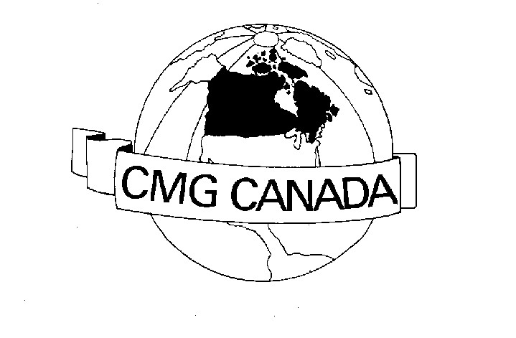
CMG CANADA MEMBERSHIP APPLICATION 2019-2020
Membership is from September to August
FEE is $100 for 4 days or $50 for one day (see membership page)
Send Interac E-Mail Transfer: to ashley.wherlan@bmo.com
do this via your financial institution’s Online Banking Facility
Send a second email using your same email you used for the
Email Transfer to ashley.wherlan@bmo.com and
include this completed form as an attachment
and provide Gabe with a clue to answer the question
you supplied in the eTransfer if your FI requires a password
or

Mail this application and cheque to: CMG Canada Inc.
63 Ferris Lane Unit B12
Barrie, Ontario L4M 5C4
Include this form in envelope with cheque

INDIVIDUAL CONTACT INFORMATION
Company
Address

Name
Phone/Fax:
Email
X

★ CMG Canada will only use your e-mail address to keep you informed of CMG Canada activities. If you would like your e-mail address to be shared with other CMG Canada related organizations, please check the box at the end of the e-mail line

